Shane Capra
IDCE 310 Intro to GIS
April 29, 2012

Lead Toxicity in Bell Hill- Predicted and Known
- Abstract
This mapping project is an effort to visually depict the predicted levels of soil contaminated by leaded gasoline as compared to the currently tested soil samples in the Bell Hill neighborhood of Worcester Massachusetts. Studies have found that leaded gasoline (used from the early twenties to 1986) may contaminate roadside soil and surfaces up to 60 meters away- with the highest levels of Pb found in the first 1.5 meters (Jaradat, 209). Youth in Charge! an environmental justice youth group that specializes in soil remediation has conducted lead tests on nearly 40 yards in the area- finding 74% of these yards containing dangerous levels of lead in the soil (>400 PPM Pb) (EHS 2). The map of this predicted Pb gasoline contamination zone does not significantly correlate with YIC!’s data- yet the maps indicate that certain areas of overlapping major road ways may have contributed to a clustering of especially high lead contamination. By focusing future testing in this cluster of high contamination risk YIC! may obtain more data to verify predicted contamination zones and focus their remediation efforts in a targeted manner.
- Introduction
Although lead is a danger most people associate with indoor spaces, lead also contaminates soil due to lead paint, leaded gasoline, and manufacturing. While lead paint indoors is often encapsulated or removed- lead contaminated is soil often overlooked or unrecognized in terms of remediation and safety. Lead contaminated soil is a risk for those with bare soil exposed in their years, those with gardens, and especially those with children and pets. Toxic soil can be carried into the home, accidentally ingested, breathed, or some instances eaten in contaminated garden produce. Lead contamination can be an extreme hazard to children younger than 16- as lead is mistaken for calcium in the body and therefore toxically remains in several body systems (de Koff et al, 1). Youth in Charge!, a small youth lead environmental justice cooperative focuses on lead issues in the Bell Hill neighborhood of Worcester MA. YIC does free lead soil testing in the Bell Hill area, educational outreach, builds raised beds for gardening, lead safe landscaping, and bioremediation.
YIC has tested nearly 40 yards in the neighborhood, finding 74% of these sites to contain dangerous levels of lead. However, YIC’s outreach and testing efforts are not based upon an overall monitor of Bell Hill soil samples or targeted predicted contamination zones. Most of the educational material YIC distributes is on lead paint soil contamination- which is not easily predicted due to a number of factors. The group has conducted little study into the contamination risks and ranges of lead contamination by leaded gasoline (which was used in the US from roughly 1921 to 1986) (Cook 131).
By researching the ranges of this contamination one may be able to visually assess the danger of this form of contamination in Bell Hill- and compare such predicted risk zones to the actual testing data of YIC. Such a comparative map would help YIC monitor an overall assessment of Bell Hill, to create a body of data testing the validity of roadside studies and Worcester’s own ranges of contamination, and to target testing and outreach efforts in a more strategic manner.
- Research Objectives
This project’s research objectives are twofold. The first is to map the unorganized data YIC has collected on their soil tests over the last 3 years. The data is largely on the parts per million (ppm) of lead found in each of the yard’s soil samples- indicating danger levels, the number of children who play in the yard, address, and a range of other disorganized material. By mapping the contamination levels and danger levels of the testing sites I will be organizing YIC’s archives into a useful data set that can be regularly updated. A graduated colors map of site polygons will depict the range of PPM or the dangerous PPM levels. Maps of the overall Bell Hill testing will help the youth coop to better understand the scope of the contamination, their coverage, and to better target their efforts. By mapping this data we will be able to overall monitor some of the trends in Bell Hill soil samples. Analysis questions such as ‘Which streets have the highest average concentrations of lead? The lowest?’ will be easily assessed- and future data can be updated into the map.
The second objective of the project is to create a map of areas likely to be contaminated by leaded gasoline due to proximity to major and non-major roadways. This material is not collected or under study by YIC, and such a map of predicted zones would enable the group to start focusing research and data collection efforts to better understand this source of lead contamination. Research into road side contamination studies and cases will allow me to create a general range for creating this map in the Bell Hill neighborhood.
The creation of these three maps (PPM Contamination, Dangerous Sites, and Predicted Gasoline Contamination Areas) will allow for an initial comparative study on predicted contamination and actual levels. If the predicted areas correlate with tested levels the maps will provide a guide to further study and targeted testing. If they do not – the maps will provide the group with zones to begin further testing to establish Bell Hill gasoline contamination ranges. In either case YIC will benefit from new educational material for both outreach and grant writing, as well as a baseline map to update and upon which to perform future analysis.

- Rationale and Literature Review
The literature surrounding the dangers of lead to health is fairly commonplace and agreed upon. Most sources report that lead is damaging because of the human body’s inability to distinguish the heavy metal from calcium- depositing the lead in several body systems and eventually storing it indefinitely in the bone structure (de Koff et al 1). According to the EPA the average child can ingest up to 200 milligrams of soil per day through putting soiled object or their hands into their mouths – in highly contaminated soils this accumulation can cause permanent damage (de Koff et al 12). Lead was commonly used in both paint and gasoline until 1978 and 1986 respectively (EPA 1 and Cook 131). Lead paint entered the soil primarily through external deterioration, poorly executed abatement and disposal, and scraping. Lead was used as an anti-knocking agent in gasoline for roughly 65 years in the US- with most of the exhaust and aerosol lead pollution eventually descending on nearby surfaces such as sidewalks, buildings, and soil. Difficult to wash away or deteriorate the lead has remained in the soil- usually in the first 6 inches (de Koff et al 2). According to W.H. Smith most leaded gasoline vehicles produced 80 mg of lead per km into the atmosphere as ‘inorganic lead salts’ (1).
YIC primarily uses the UMass Memorial testing labs for their soil samples. The UMass Lab indicates that The UMass Memorial soil testing lab indicates that levels from 0-299 ppm are low, 300-999 medium, 1000-1999 high ,and 2000+ are very high (43). However, the consensus both in legalistic terms and in the literature is that anything above 400 PPM is to be considered dangerous to children below the age of 16 (de Koff et al, 2 and EHS Labs, 2). When YIC did their analysis in 2010 they found that 70% of the sites they had tested were above this threshold of 400ppm- with a maximum of 4,826 ppm. Naturally occurring Pb in soil range from 10-70 ppm (de Koff et al 2). This indicates an extremely high level of soil contamination in much of the Bell Hill area- which YIC seeks to explain. Having studied external lead paint as a contributor, YIC is beginning to research the contamination added in by gasoline pollution.
YIC has not conducted any studies of roadside contamination specifically. Therefore a precedent for contamination ranges from roads had to found from the literature. However, the available studies of lead contamination of soil and leaded gasoline revealed that the extent of the contamination was great-but with little consensus on contamination ranges from roadways. The range of where this gasoline contamination is thought to have settled is debated- anywhere from 5 mile to entire cities (Cook). Overall it seems that there are many more variables that cause each roadway and city to have different ranges- making a universal precedent non-existent. One study conducted in Jordan found decreasing contamination at ranges of 1.5 and 10 meters with all contamination tapering off at around 60 meters (Jaradat 209). Another study in Alaska indicated that in order to measure ‘natural’ levels of contaminants in soil they only took samples 100 meters from any road (Gough 1). A 2005 Indianapolis study was performed on a busy urban street and found that dangerous levels did not dip below 400 ppm after 140 feet (de Koff et al 2). Others included 40 meters (at least 2-6 times the natural levels) and 25-150 ft in urban areas (Ata, 1 and Hunter 155). The consensus was that in all cases the traffic density, wind direction, number of surfaces that would block or collect the lead residues from the soil, and stacking of roadways had large impacts on contamination (Ata, 1 and Hunter, 155 and Jaradat, 209).
This many variables is out of the range of this brief study, but will be taken into account in future work. For the time being I needed to create a precedent from which YIC could begin its own studies. Therefore I chose to use the ranges of 1.5 meters, 10 meters, and 60 meters as the predicted contamination zones- as they were used in Jordan as a well as an aggregation of US city data on lead contaminations (Jaradat 213).
- Data
The first data sets were pulled from the MassGIS website’s MA Census 2010 databases. Layers pulled include Census2010TigerRoadsArc, Census2010Parcel Polygons, and Census2010 Addresses. The second data sets were based upon the ranges of contamination off of major highways in the “Contamination of Roadside Soil, Plants, and Air With Heavy Metals in Jordan, A Comparative Study.” The final data set are the Soil Test Results from the YIC archives- including data on PPM, danger levels, and number of children.
Although the sister organization of YIC (the Toxic Soil Busters) has done extensive testing in Main South over the course of seven years- YIC is a much younger program focused on the Bell Hill area. This means that the sites tested totals to only 39. The greater bulk of the YIC archives are disorganized and incomplete- so the creation of this map has solidified and cleaned up the data.
The study area for the project is Worcester, MA- but more specifically the Bell Hill area which roughly spans from Summer street, the edge of Shrewsbury st, up Belmont ave, through Green Hill Park and hedged by Lincoln Ave. It is a large area that is largely residential, with the UMass hospitals and campuses running throughout, and Plumley Village housing project and 290 cutting through its middle. The area is a known food desert- and recent attempts at community gardening only intensify the need for remediation and outreach on heavy metals in the soil. In 2010 70% of the total sites tested by YIC have dangerous lead levels- with a high point of 4826 ppm. To my knowledge the testing data has only ever been mapped using google maps- and the subsequent maps were not used for analysis.
Table 1.
Name | Format | Source | Date Created | Organization
“Contamination of Roadside Soil, Plants, and Air With Heavy Metals in Jordan, A Comparative Study” | Contamination range Data | Qasem M. Jaradat and Kamal A. Momani | 05/01/1998 | Chemistry Department, Mu'tah University, Al-Karak JORDAN
Census2010TigerRoads_Arc | Vector Line | MassGIS | 4/17/2012 | Mass State Gov
gismapping_GISDATA_Basemap_Parcels_Polygons | Vector Polygon | MassGIS | 4/17/2012 | Mass State Gov
gismapping_GISDATA_Basemap_Parcels_Addresses | Vector Point | MassGIS | 4/17/2012 | Mass State Gov
Testing Results | Text/integer tables | Youth in Charge! Archives | 2007 | Youth In Charge!

- Methods
My first step was to isolate and input my data. First I used a select by attribute to isolate the only the streets of Worcester from the larger Massachusetts Tiger roads shapefile. Next I compiled and organized the YIC archives into a more useable excel document that included addresses, number of children, ppm, danger level. I then used select by attribute on the Census 2010 addresses shapefile to create a layer of the streets with sites sampled by YIC. From this I performed a second select by attribute query to create a layer of only the addresses tested by YIC. The unique value used was street and number. Creating a layer from this selection I then had a simple map of sites tested in the form of point data- but I needed to map polygons if I was to create a more useful comparative map.
To insert the YIC testing archives lead level data into the address data I created a new field in the attribute table called ‘Total_PPM’, and used edit to insert the highest PPM samples from each site. I then re-projected any layers that differed into NAD_1983_StatePlane_Massachusetts_Mainland_FIPS_2001_Feet using Lambert_Conformal_Conic (GCS _North_American_1983). I then performed a simple join of the Site data to the Census2010 parcel polygon data – using LOC_ID. This was actually a join with bad cardinality as it was many to many- yet this was a temporary table join that I was using to convert my addresses to parcel polygons. I selected the meaningful LOC_IDs and scrapped the rest. The results in having YIC sites in parcel polygons- with both address and Total PPM data intact.
I then create the map of contamination levels by PPM by graduating the polygon colors using a manual set of classifications based upon those of UMass Memorial’s testing labs. I also created a graduated color map using classification of 0-399 and 400+ to create a map of the sites dangerous to inhabitants.
This first phase of my mapping resulted in the known contamination levels in Bell Hill sites- and the second phase is the creation of prediction zones. First I ran a buffer of 1.5 meters (all dissolve) on the Worcester Roads file. This area as described by Jaradat is the area of most likely and highest contamination. I then ran a second buffer on the Worcester Roads shapfile of 10 meters (all dissolve)- replicating the middle ranges at which Pb levels fall. Finally I used attribute select to create a layer that was only the major roads (Belmont Ave, Lincoln Ave, 290) and ran a buffer of 60 meters (all dissolve) on that. This replicated the 60 meter point indicated to be the point at which lead contamination is largely negligible or similar to natural levels. Had I done a 60 meter buffer on all of the roads the resulting area would have entirely covered Bell Hill. Therefore I focused only on the roads with the heaviest traffic – knowing that traffic density will extend the range and levels of contamination.
I then ran intersect on the each of the three buffers with the Site polygons- and then an intersect between each of the buffers and polygons to see where contamination predicted overlapped and created higher probabilities of lead exposure. I then Graduated the intersecting areas to create a map of areas most likely to be contaminated by leaded gasoline.
- Results and Discussion
Visually analyzing the Contamination in PPM map it is easy to see that there seems to be little correlation between the level of tested lead and the predicted gasoline contamination zones. There are numerous green low PPM sites within the larger buffers and although many sites have a slight area that is in the medium risk buffer of ten meters there seems to be no pattern. Switching to the Dangerous Sites map reveals just how much the UMass classifications masked the danger levels in the neighborhood. Now it is easy to see that the 2012 data brings the dangerous site percentage up to 74%. A number of red dangerous sites are in the buffer zones- but there are also a handful of very low lead ppm sites with large areas in the zones.
In order to prove this inconclusive correlation between the predicted contamination and the tested contamination levels I created a scatter plot and ran a linear regression which turned up” y = -0.3183x + 1211.3, R² = 0.0145” which is fairly insignificant and inconclusive.
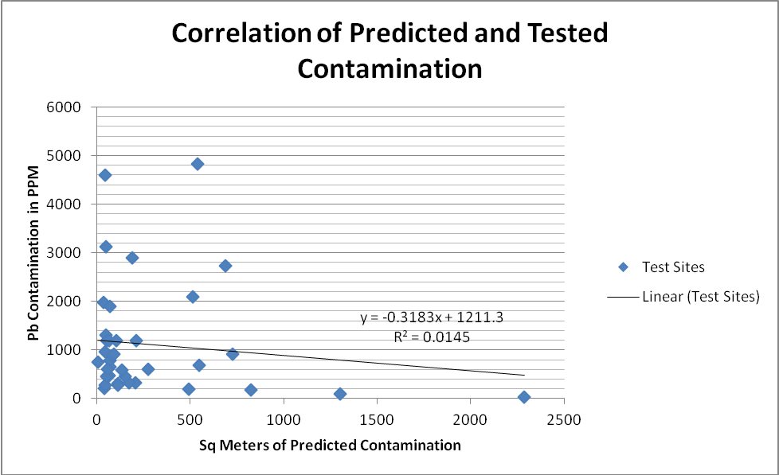
This inconclusive relationship has a number of factors explained by the literature review- namely that there are an extreme amount of variables at play. Factors like wind direction, traffic patterns, slope of drainage, the way building surfaces alter the patterns of contamination on the ground, manufacturing zones in the area. Each roadway will have a different range and level of contamination- meaning that many ranges may exist just within Bell Hill. Data can also be skewed by the number of homes contaminated by lead paint as opposed to roadside pollution-many of our test sites simply aren’t in the predicted zones. Perhaps the most significant reason is that we simply do not have enough data to really prove anything- especially since YIC has never tested soil next to roadsides- but rather only yards of houses. We will continue to collect data, hopefully beginning to build a database on roadside contamination samples.
One interesting element that Hunter talks about in his study of ‘Aerosol and Roadside Lead’ the concept of the ‘stacking’ of major roads having a cumulative impact on a sites lead levels. Areas such as highways, overpasses, intersections, exits, and ramps all ‘stack’ contamination sources on top of or very close to one another. One of the few clusters of extremely high lead levels that did intersect with the contamination zones is in one of these ‘stacks.’ The area around Kendall St. and Auburn Ave is a stack of Lincoln st, I290, an on ramp, and several non-major roads. Auburn has the highest site YIC has tested so far, and another site there is in the 2,000s. Combined the four sites have an average PPM of 2288.5- several times over the maximum safe ppm of 399. In this stack the buffers begin to layer one on top of the other- creating higher levels of exposure than normal. Bell Hill has a few such ‘stacks,’ but I focused on this area as it is the only such ‘stack’ to be nearby our tested sites. Mapping this overlap will allow us to further investigate the contamination levels there- and possibly become a target area for the Summer’s remediation.
So while the mapping project has succuessfully visually demonstrated the degree of contamination in Bell Hill- it is only a first step in learning about roadside toxicity.
- Conclusion
While the final comparative analysis of the maps proves inconclusive for use in studying roadside contamination in Bell Hill- it has pointed us in several new directions. Conducting new research into Bell Hill’s contamination ranges and roadside levels, focusing our educational outreach and efforts at testing and remediation. This is especially true of the Kendall-Auburn ‘stack’ which may prove to be an extremely toxic area in need of remediation overall. Although this study was brief and superficial-it also points towards what sorts of variables we should take into account in conducting future research or mapping.
The maps will provide us with valuable monitoring baselines for Bell Hill and our work- which we can update and analyze when needed. The maps will also be useful in educational settings during outreach and in grant writing- as the danger sites map especially indicates the need for remediation efforts. For now the maps will be used as ‘Walking Maps’ to help us to target our organizing.
- Bibliography
Ata, Sibel, and Taskin Oztas. "Distribution patterns of lead accumulation in roadside soils: a
case study from Erzurum, Turkey." International Journal of Environment and Pollution 17.3 (2003): 190. AcademicOneFile. http://go.galegroup.com/ps/i.do?id=GALE%7CA143293697&v=2.1&u=mlin_c_clarkunv&it=r&p=AONE&sw=w. Web. 29 Apr. 2012.
Cook, R. Dennis. Liqiang Ni. “Elevated Soil Lead: Statistical Modeling and Apportionment of
Contributions from Lead-Based Paint and Leaded Gasoline.” The Annals of Applied Statistics, Vol. 1, No. 1 (Jun., 2007), pp. 130-151. Published by: Institute of Mathematical Statisticshttp://www.jstor.org/stable/4537425.Accessed: 29/04/2012
De Koff, Jason P. Brad D. Lee, and A. Paul Schwab. “Home & Environment :Protecting Your
Family from Lead in the Home.”2007.Purdue University Department of Agronomy.
Environmental Hazards Services, L.L.C. “Lead in Soil Analysis Report.”
Gough, L. P., R. C. Severson, and H. T. Shacklette. “Element Concentrations in Soils and
Other Surficial Materials of Alaska.”1988. U.S. Geological Survey professional paper.
Hunter, John M. “Aerosol and Roadside Lead as Environmental Hazard.” Economic Geography,
Vol. 52, No. 2, Human Health Problems: Spatial Perspectives (Apr., 1976), pp. 147-160 Published by: Clark University. <http://www.jstor.org/stable/143361>
Jaradat Qasem M. Kamal A. Moman_I. “Contamination of Roadside Soil, Plants, and Air With
Heavy Metals in Jordan, A Comparative Study.” 1999.Chemistry Department, Mu'tah University.
Smith, W.H. “Lead contamination of the roadside ecosystem.” Jan. 1, 1975. Annu. Meet., Air
Pollut. Control Assoc. Journal Volume: 68; Conference: Annual meeting of the air pollution control association, Boston, MA, USA.
UMass Extension. Soil and Plant Tissue Testing Laboratory. Soil Lead Levels: Interpretations
and Recommendations.
United States Environmental Protection Agency. Office of Pollution and Toxics. Testing Your
Home for Lead: In Paint, Dust, and Soil. July 2000. http://www.epa.gov/lead/pubs/leadtest.pdf
- Figures
Figure 1. Model Builder
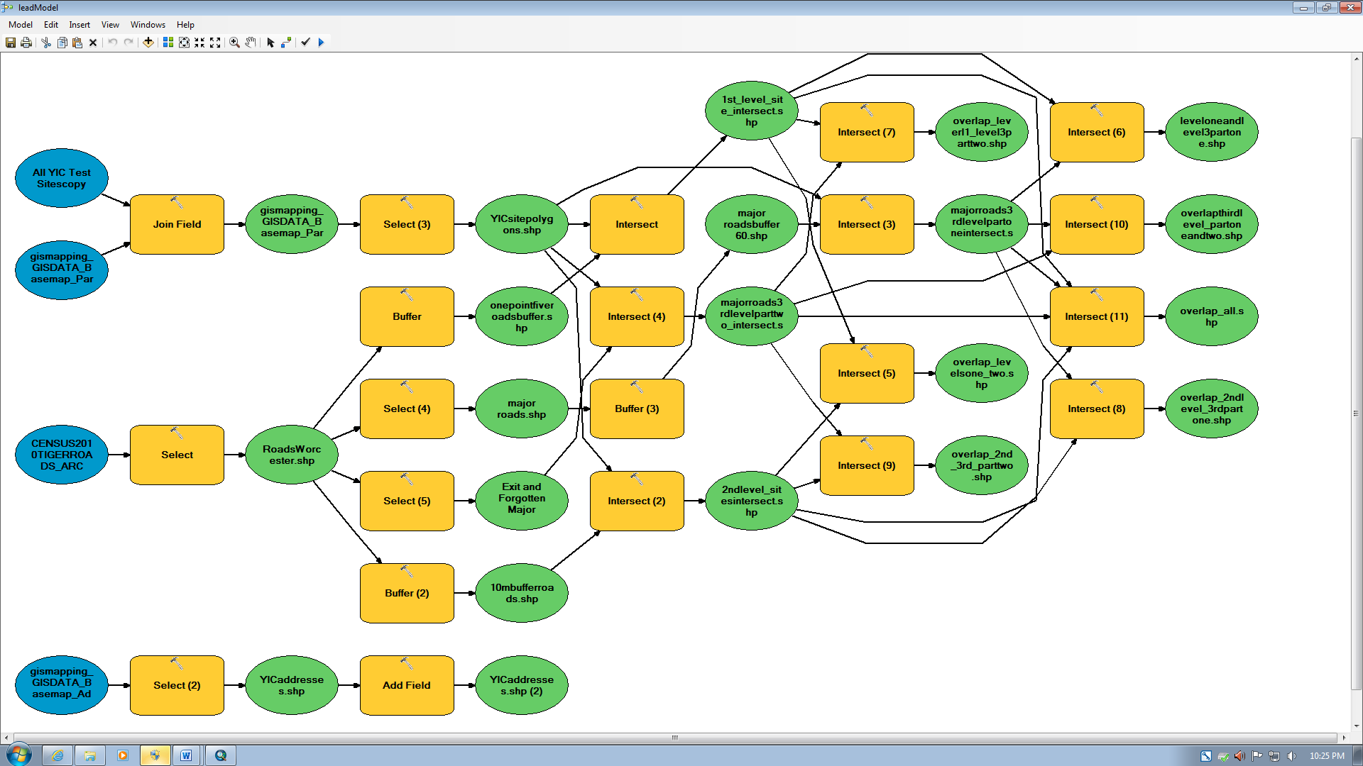
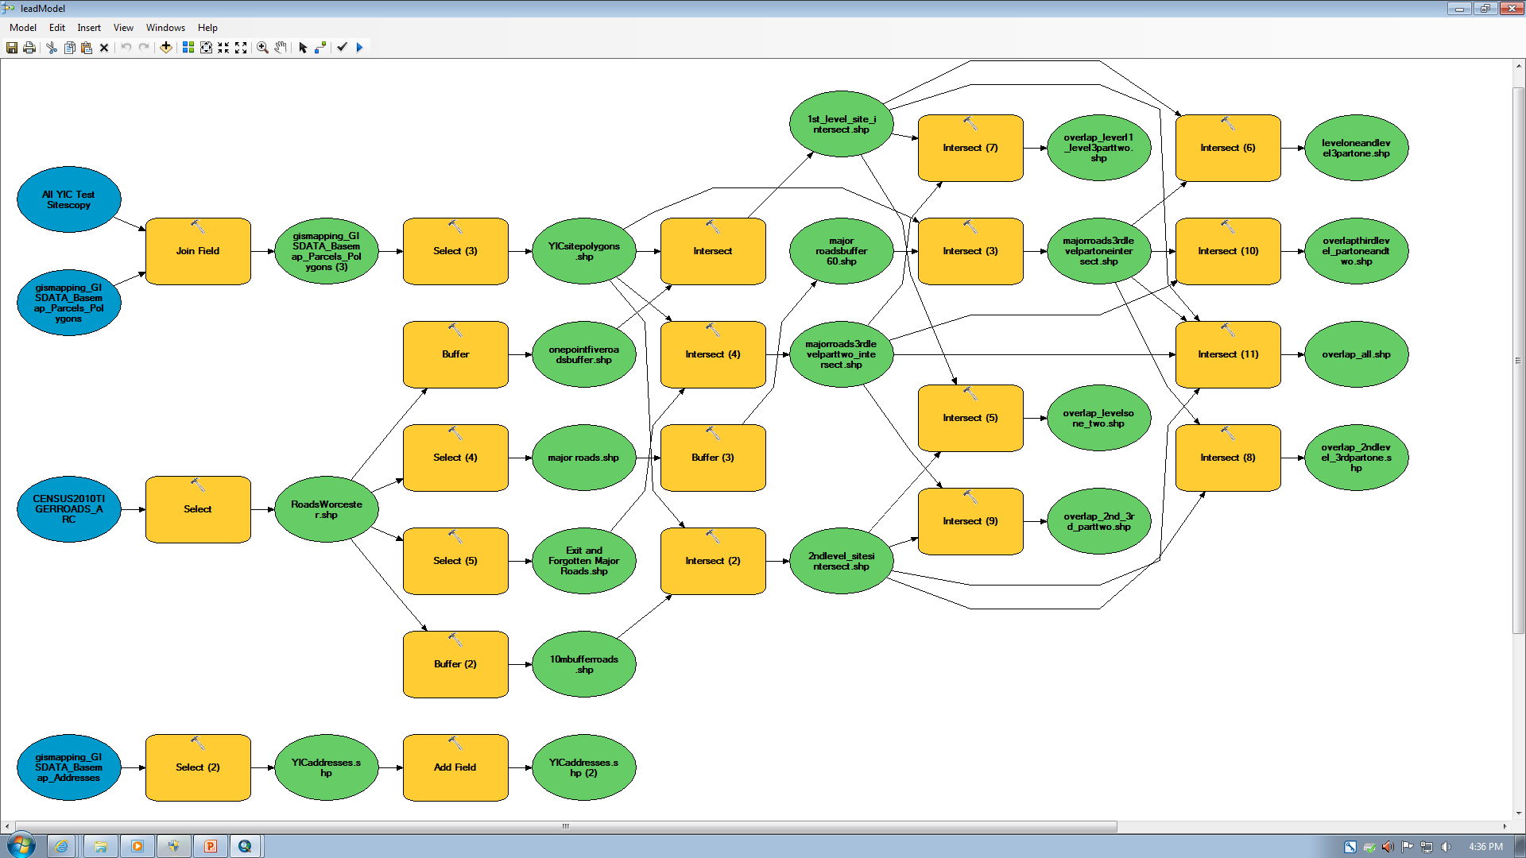
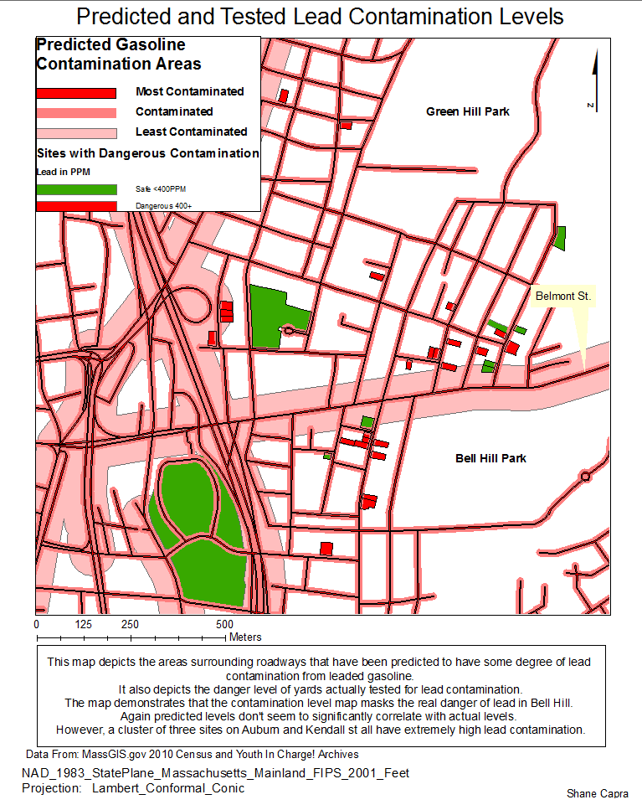
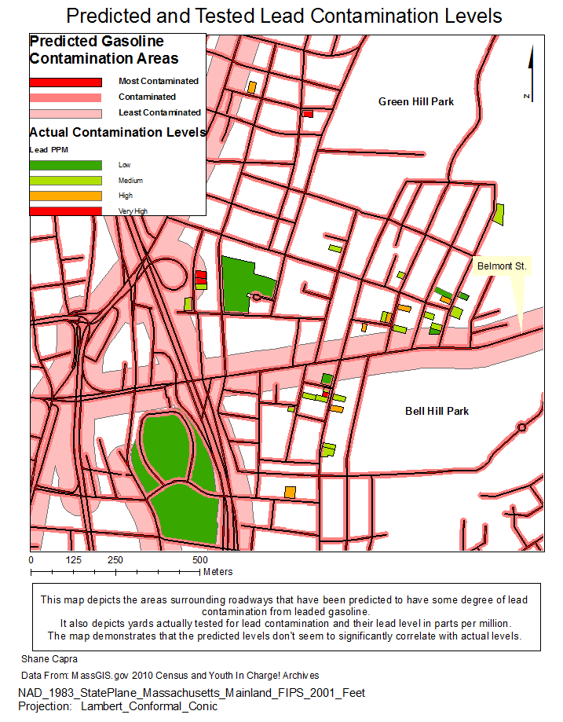Figure 3
Figure 2. Predicted Contamination and Known PPM Contamination

Figure 4.

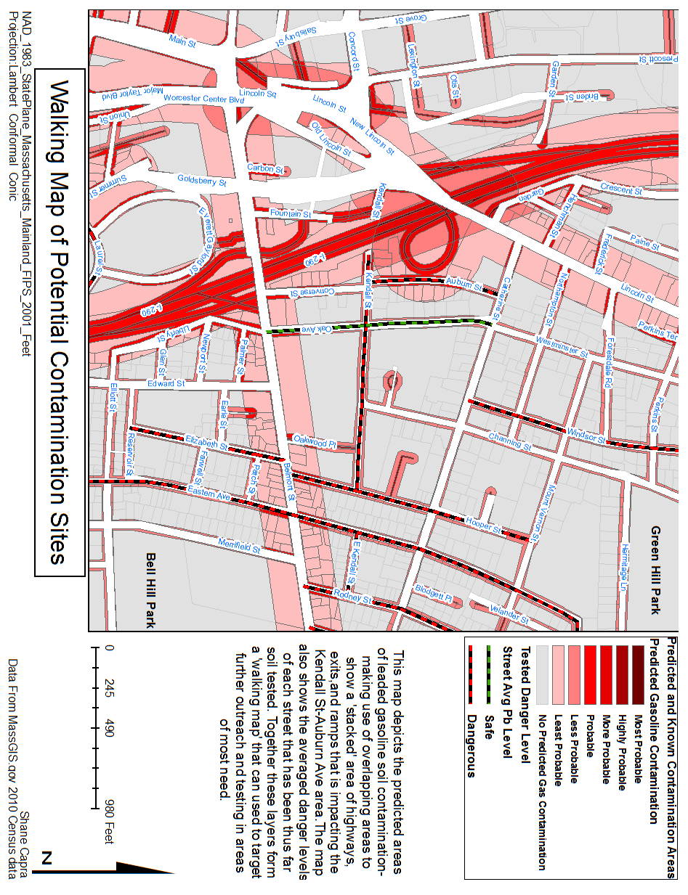

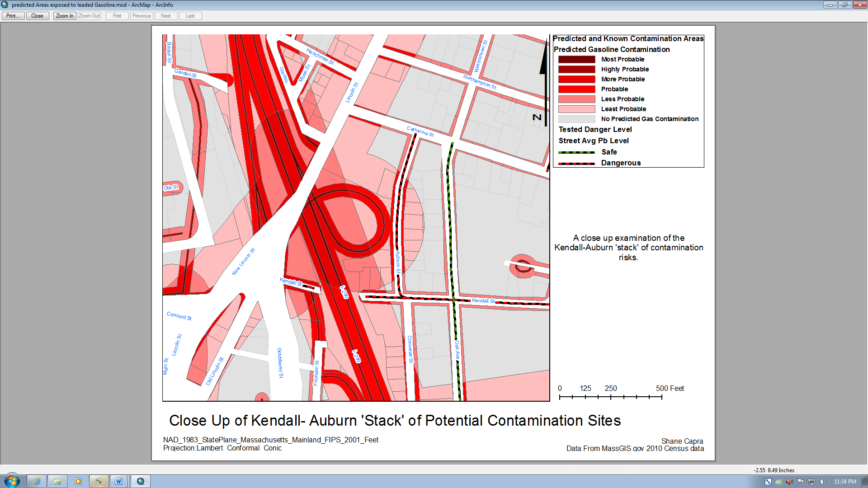
Figure 5
