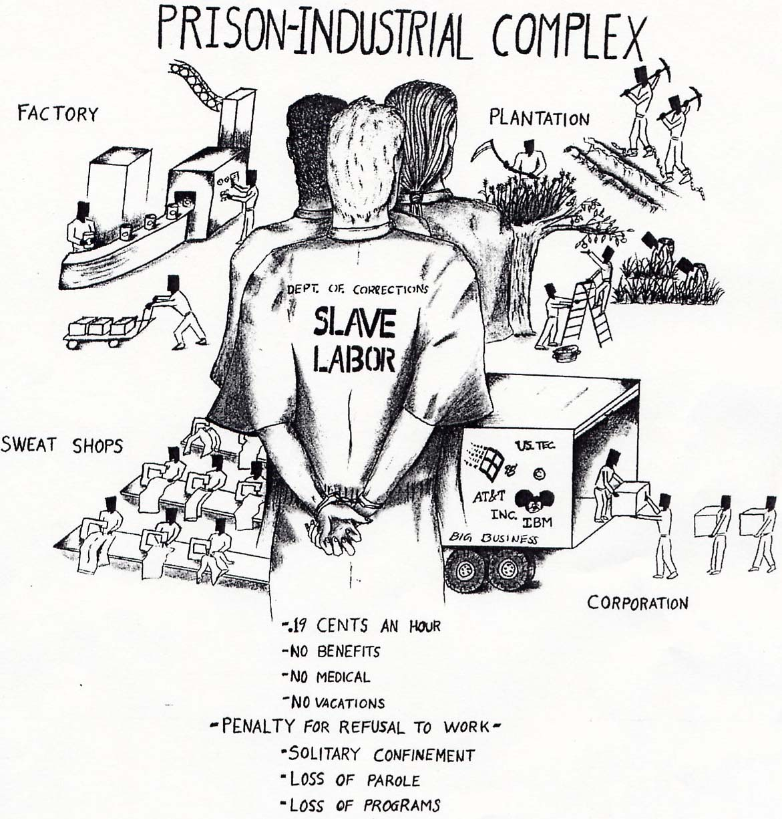
Prison Industrial Complex Workshop
Created 3-31-15
for Toxic Soil Busters
www.WorcesterRoots.org

Materials Needed:
- Copies of 3 pages from Critical Resistance's Toolkit: P 59 – 61
- 3 computers with internet access.

1. Introduction / Warm Up Activities (10 mins)

Theater of the oppressed games “bombs and shields” and “French Telephone/Do Nothing”
http://organizingforpower.files.wordpress.com/2009/03/games-theater-of-oppressed.pdf
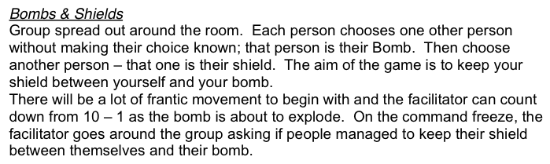
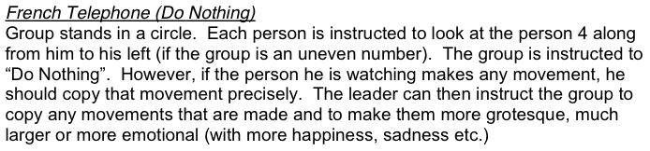

2. Terminology (25 mins)
Split into 3 groups by counting off.
Each group take a term: Prison Industrial Complex, Abolition, The State bring back a creative report to group (news report, poem, skit, drawing).
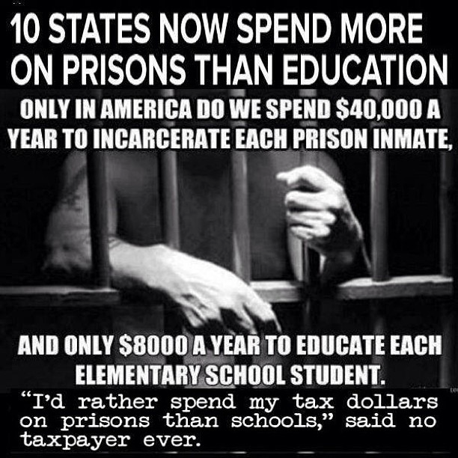
Discussion after each report back. For example after abolition report, discussion on “Can you envision a world without prisons?”.

3. Let's Find Out More Together about Prisons (35 mins)
a) While still in same small groups, each group picks a topic
(Ex. Food in prisons, Race and prisons, Gender and prisons).
b) Groups have 15 minutes to investigate their topic online, sample websites:
http://c4ss.org/content/30340
http://criticalresistance.org
http://abolishprisons.org
http://www.blackandpink.org/prison-abolition-class/
c) Groups come up with list of 10-20 most amazing facts about their topic (save this list for later).
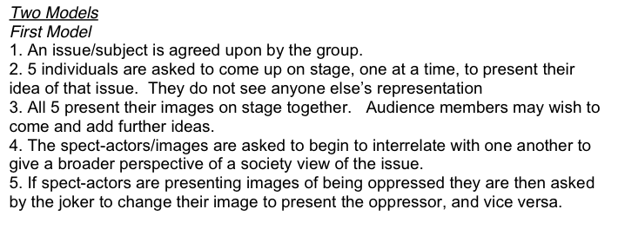
d) Two Models (Forum Theater) in Cafeterias
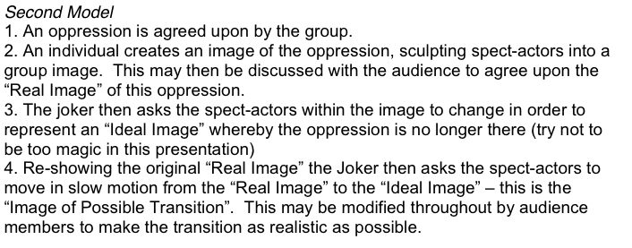
4. Evaluation
What is one take away from the workshop and one thing that could be done better next time.

