Sample Sales Funnel
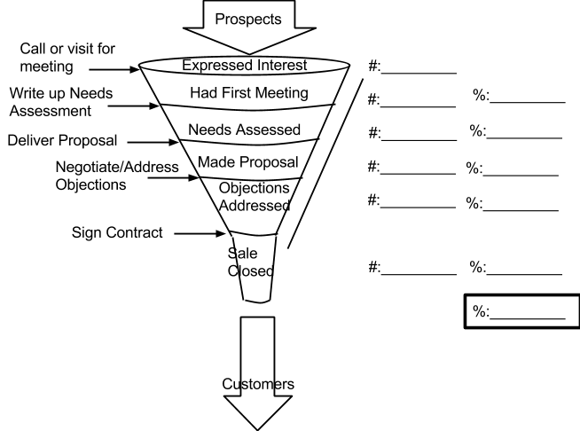

<--Percent of interested people that
agree to initial meetings
<--Percent of initial meetings that agree to needs assessments
<--Percent of Needs Assessments that get Proposals
<--Percent of Proposals that express objections/are open to negotiation
<--Percent of Negotiators that sign contracts
<--Overall percentage of prospects that became customers

Prospects are generated by marketing activities. A prospect is any person that you can identify by name, who is likely to want your product or service. Every time you collect a group of names, such as a sign up list at a fair or festival, a group of people that signed up for your email newsletter in a given month, or a cohort of people who called as a result of a listing you placed in a local newspaper, you can track that group through the sales process to find out how many eventually become customers. This will help you focus your marketing efforts to generate prospects that lead to a good quantity of sales.

